**UNIT – IV**

**Water Softening:**

**Methods for removing temporary hardness:**

1. **Boiling:**

* Calcium carbonate – slightly soluble – usually exists in water as calcium bicarbonate. Easily dissolves in water containing Carbon dioxide.

Ca(HCO3)2 + Heat CaCO3 ↓ + CO2 ↑ + H2O

Cal. Bicarbonate Cal. Carbonate (insoluble)

* Magnesium bicarbonate and carbonate – not removed satisfactorily by boiling.
* Magnesium carbonate fairly soluble in water – boiling cannot remove temporary hardness removed by magnesium.
* Boiling – not feasible – large scale supplies.
* On the other hand magnesium carbonate and bicarbonate are removed by precipitating them as insoluble magnesium hydroxide, by treating that hard water with lime – also removes calcium bicarbonate as calcium carbonate by supplying OH- ions.

**2. ADDITION OF LIME:**

* Lime (CaO), generally hydrated lime is added to water following reactions takes place.

**MgCO3 + Ca(OH)2 Mg(OH)2 ↓ + CaCO3 ↓**

Mag. Carbonate Hydrated Lime Mag. Hydroxide Cal. Carbonate

(soluble) (insoluble) (insoluble)

**Mg(HCO3)2 + Ca(OH)2  Ca(HCO3)2 + Mg(OH)2 ↓**

Mag. Bicarbonate Hydrated lime mag. Hydroxide

**Ca(HCO3)2 +Ca(OH)2  2CaCO3 ↓ + 2H2O**

cal. bicarbonate

* Calcium carbonate and magnesium carbonate are precipitated and can be removed.
* This method is generally adopted for softening waters which contains only temporary hardness.
* Temporary and permanent hardness are softened by special methods.

**PERMANENT HARDNESS:**

* Permanent hardness is more difficult to remove. It can be removed by special methods generally called water softening methods.

1. Lime Soda process

2. Base exchange process called Zeolite process and

3. Demineralization process

1. **Lime Soda process:**

* Lime and soda ash are added to hard water – reacts with calcium and magnesium salts – to form insoluble precipitates of calcium carbonate and magnesium hydroxide.
* These precipitates can be sedimented out in a sedimentation tank. The chemical reactions which may be involved are :

**Ca(HCO3)2 +Ca(OH)2  2CaCO3 ↓ + 2H2O**

carbonate hardness of Ca Lime

**Mg(HCO3)2 + Ca(OH)2  Ca(HCO3)2 + Mg(OH)2 ↓**

carbonate hardness of mg Lime mag. Hydroxide

**MgCO3 + Ca(OH)2 Mg(OH)2 ↓ + CaCO3 ↓**

Carbonate hardness of Mg Mag. Hydroxide Cal. Carbonate

**MgCl2 + Ca(OH)2 Mg(OH)2 ↓ + CaCl2**

Non-carbonate Lime Non-carbonate

hardness of Mg hardness of Ca

**MgSO4 + Ca(OH)2 Mg(OH)2 ↓ + CaSO4**

Non-carbonate Non-carbonate hardness of Mg hardness of Ca

**CO2 + Ca(OH)2  CaCO3 ↓ + H2O**

Free dissolved CO2

**CaCl2  + Na2CO3 CaCO3 ↓ + 2NaCl**

Non-carbonate Soda Ash

hardness of Ca

**CaSO4 + Na2CO3 CaCO3 ↓ + Na2SO4**

Non-carbonate Soda Ash

hardness of Ca

* Sodium salts formed in the reactions are not objectionable.
* Most of the CaCO3 and Mg(OH)2 are precipitated and sedimented out in the Sedimentation tank.
* Little quantity may remain as finely divided particles, may cause troubles by getting deposited on the filter to cause enlargement of the sand grains called incrustation of filter media or in the pipes of distribution system.
* To prevent this, it is generally necessary that the water to be re-carbonated by passing carbon dioxidegas through it.
* In this process insoluble carbonates combines with the carbon dioxide to again form some soluble bicarbonates.

**CaCO3 ↓ + CO2 + H2O Ca(HCO)3 ↓ (hardness)\***

Insoluble cal. Carbonate soluble cal. Bicarbonate

**Mg(OH)2 + CO2 MgCO3 + H2Oi**

**MgCO3 + CO2 + H2O Mg(HCO3)2**

* The carbon dioxide gas – blown in water – produced by burning coke, gas or oil or delivered to the plant as a pressurized liquid.
* Quantity of lime and soda depends – chemical quality of water, desired hardness removal.
* Many of the hard waters may primarily contain carbonate hardness and very low amount of non – carbonate hardness. (so lime is often the only chemical required)
* Detention period - 2 to 4 hrs.
* Lime soda ash softening plant is shown in below fig.

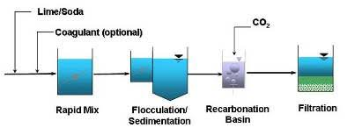

**Advantages:**

1. Process is economical.
2. Easily combined with usual water treatment methods, without much extra trouble or cost.
3. Dose requirement is less – when compact units are used.
4. Treatment leads – increase in pH – reduces corrosion of pipes – increases causticity – kills the pathogens – happens when alkalinity caused by calcium and magnesium upto 20 to 50 mg/l is retained in the treated water for about 4 to 5 hrs.
5. Reduces mineral content
6. Helps in removing iron and manganese from the water upto certain extent.

**Disadvantages:**

1. Quantity of sludge is more – used for raising low lying areas or released into sewers.
2. To get good results – careful operation – skilled supervision.
3. Incrustation of pipe walls of the distribution system - if water is not properly re-carbonated.
4. Process cannot help in producing zero hardness – removes upto 50mg/l.
5. **Zeolite Process or Base Exchange or Cation Exchange Process:**

* Lime soda process is chemical oxidation and precipitation method (chemicals are added)
* Zeolites are the natural salts (green sand) or clays which are hydrated silicates of sodium and aluminium having formula Na2OAl2O3 x.SiO2 y.H2O
* Usual value is 2 or more, and that y of ranging amounts.
* Synthetic zeolite substances are calledresins.
* Zeolites or resins have excellent cation exchange property.
* During softening process – sodium ions of the zeolite get replaced by the calcium and magnesium ions present in the hard water.

(HCO3)2 (HCO3)2

Ca Ca

Na2Z + SO4  Na2 SO4  + Z

Mg Mg

Cl2 Cl2

Sod. Zeolite cal. or mg. salt sodium salts Ca or Mg Zeolite

don’t cause hardness

* Calcium and magnesium zeolite can be regenerated into active sodium zeolite by treating 5 – 10% of sodium chloride.

Ca Ca

Z + 2NaCl Na2Z + Cl2

Mg Mg

Used Zeolite sodium chloride sol. Regenerated zeolite

* A zeolite softener resembles a sand filter in which the filtering medium in a zeolite rather than sand.
* Green sand has exchange value of 6500 to 9000gm of hardness of m3 of zeolite.
* Artificial zeolite ( permuit manufactured from feldspar, kaolin, clay and soda ) – 35000 to 40000gm of hardness of m3 of zeolite.
* Zeolite is regenerated with 10% solution of brine, excess brine solution is removed in the zeolite with fresh water.
* Zeolite softeners may be either gravity type or pressure filters.
* Rate of filtration through a zeolite softener – 300 lit/sq.m/min.
* Zeolite process – zero hardness – not suitable for public supplies – but for industries.

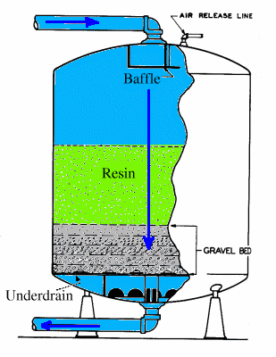

Fig: Zeolite water softener

**Advantages:**

1. Zero hardness – useful for textile industries, boilers.
2. Plant is compact, automatic, easy to operate.
3. No sludge is formed, no problem of sludge disposal.
4. RMO cost is quite less.
5. Removes ferrous, manganese.
6. No problem about varying quality.
7. No incrustation problem.

**Disadvantages:**

1. Not suitable for highly turbid water.
2. Leaves sodium bicarbonate – causes priming and foaming.
3. Costlier and unsuitable for water containing iron and manganese.
4. Iron or manganese zeolite cannot be regenerated into sodium zeolite. Even removal of iron and manganese – achieved – zeolite (changed)

**3. Demineralisation process:**

* Raw water first passed through cation exchange resign, after that passes through anion exchange resign.
* Process of passing of water through cation exchange resigns produces almost similar effects as zeolite process. Except hydrogen (instead sodium) is exchanged for basic metallic ions.
* Cation exchange resins – phenol aldehyde condensation products, sulphonation produces resinous mass having base exchange properties.
* Chemical formula is H2R

Ca(HCO3)2 + H2R CaR + 2H2O + 2CO2 ↑

Fresh cation Exhausted

exchange resin Resin

CaCl2 + H2R CaR + 2HCl

MgSO4 + H2R MgR + H2SO4

2NaCl + H2R Na2R + 2HCl

* Water coming amount of cation exchange resign – now contain diluted acids – removed by passing through anion exchange resin.
* Anion exchange resins – condensation of formaldehyde products, which are capable of replacing anions with their hydroxyl ions.
* Chemical formula is ROH.

ROH + HCl RCl + HOH

Fresh anion Exhausted Water

exchange resin Resin

2ROH + H2SO4 R2SO4 + 2HOH

Fresh anion Exhausted Water

exchange resin Resin

* Water coming out from this anion exchange resin will be free from minerals.
* Extent of removal will depend upon the strength and freshness of the resins used.
* Completely demineralized water – added to raw water (sometimes).

Regeneration of cation exchange resins:

Ca Ca

Mg R + 2HCl H2R + Mg Cl2

Na2 Na2

Exhausted cation Regenerated cation

exchange resin exchange resin

Ca Ca

Mg R + H2SO4 H2R + Mg SO4

Na2 Na2

Exhausted cation Regenerated cation

exchange resin exchange resin

Regeneration of anoin exchange resins:

RCl + Na2CO3 + 2H2O 2ROH + 2NaCl + 2CO2 + H2O

Exhausted anion Regenerated anion

Resin resin

**DESALINATION:**

Only 0.5% of the earth’s water is potable, remaining 97% is ocean water is highly saline having a dissolved salt content about 35000mg/l and the remaining 2.5% of water is brackish having dissolved salt content of 1000 to 3000 mg/l which is too salty for consumption. The process of converting saline water to fresh water is known as desalination.

Following are the methods used for desalination.

1. **Reverse Osmosis:**

* Osmotic pressure is proportional to the TDS of water, and twice the osmotic pressure is required to achieve economically feasible flow.
* Semi permeable membrane – thin but dense – strong enough to withstand pressures.
* It is supported by a grid.
* RO does not work below 60000 KN/m2 to 100000 KN/m2
* Semi permeable membranes, have been used for separating the materials according to the physical and chemical characteristics.
* Pressure driven forces can be broadly classified according to the membrane pore size and size of particles removed.

1. Micro filtration

2. Ultra filtration

3. Nano filtration

4. Reverse osmosis

* NF and RO helps in filtration of dissolved salts, NF considered to be part of RO and is known as low pressure reverse osmosis.
* Both these NF and RO help in removal of ions by osmosis, while MF and UF are micro porus membranes – removes suspended particles of small size.
* MF and UF are low pressure processes.
* NF and RO are high pressure process.
* RO rejects particle size – 0.0001µm, NF rejects – 0.001 µm.
* RO used – desalination with low pressure membranes(NF) of moderately salt water (TDS – 1000 to 10000 mg/l) – with high pressure membranes(TDS 10000mg/l). Good water – 500 mg/l can be obtained.
* Used mostly in North America and Middle East Countries and in coastal cities like Chennai, Kanda, Bhavnagar.

1. **Distillation:**

* This is the best of all the methods and most commonly used, now a days 95% salt water is treated by these methods removing salt and other impurities from the water.
* Saline water is boiled or evaporated using steam in a suitable vessel to produce vapours of pure water and a liquid residue of highly concentrated salt solution or brine.
* Then the vapours are condensed which gives fresh water.
* Sea water is complex mixture of dissolved and marine life, can attach itself to the heat transfer areas and developing blanket causing fouling.
* To minimise these effects, pre-treatment of sea water is essential.
* Marine life is eliminated by chlorinating the raw feed to kill any existing organisms and to prevent subsequent growth.
* These are the various methods of distillation, all these methods heat the salt water to vapour stage and then condense it to water forms by suitable cooling methods.

1. **Electro - dialysis:**

* In salt water H2O molecules are bonded together with sodium and chlorine ions, these hydrogen-bonds must be broken up in order to pulled out of the cations and anions from the water by thin sheet membranes that are selectively permeable to different types of ions one more selective to anions and other more selective to cations.
* These bonds were broken by heat in the method of distillation while in the electro-dialysis method are broken with the help of electricity.
* When the current is passed through the salt solution, the sodium and chlorine gets freed from water molecules and they start moving towards their oppositely charged electric poles.
* The positive charges of sodium ions moves towards negative pole (cathode), while negative charges of chlorine ions moves towards positive pole (anode).
* These cations and anions permeate through respective membranes and are allowed to separate in different compartments, water becomes free from salt.
* Electric energy required is proportional to the concentration of salts and this method

is suitable especially for brakish waters with total concentrations of saline constituents up to 5000 mg/l and leaving at least 100 mg/l in treated water.

1. **Desalination by freezing:**

* In this method temperature of saline water is gradually lowered until ice crystals are formed.
* These crystals are very small (0.05 mm in size) and entrap large volume of brine water. These formed crystals are separated, melted, melted water is the fresh water.
* In direct contact refrigerating system, liquefied hydrocarbons is mixed with sea water.
* Another system known as the pressure freezing process, a high-boiling hydrocarbon is frozen and mixed with pre-chilled sea water.
* The ice is decanted from the mixture after the frozen hydrocarbon is melted and is washed and then mixed with liquid hydrocarbon and is subjected to a pressure of about 140 kg/cm2.
* This method is in developing stage. Cost of production is high.

1. **Desalination by Solar distillation method:**

* All the desalination methods described above needs a lot of thermal energy or mechanical power, where in solar evaporation, solar radiation is used as the source of heat energy.
* This is old method.
* Billions tones of sea water evaporates – lifts the vapour to clouds.
* Basin is created and salt is allowed to it. Basin covered with glass or plastic covers, which stops and collects the vapours.
* Costliest process- investigations are still going.

1. **Other methods:**

* Propane gas mixed with salt water under controlled temperatures and pressure.
* Chemical reactions between propane gas and water takes place, higher temperature than freezing, forming ice like crystals.
* Crystals are separated from the brine, washed and decomposed to form water.
* Propane gas released during decomposition can be reused.
* Investigations are going on to convert sea water into useful water with moderate cost.

**Selection of particular method:**

|  |  |  |
| --- | --- | --- |
| **S. No** | **Desalination Process** | **TDS value of salty water to be treated in mg/l** |
| 1 | Ion exchange | Up to 500 |
| 2 | Electrodialysis | 500 – 3000 |
| 3 | Low pressure osmosis including NF | 1000 – 10000 |
| 4 | High pressure RO | 10000 and above |
| 5 | Distillation | Above 30000 |

**REMOVAL OF IRON AND MANGANESE:**

* Iron and manganese exists in invisible dissolved state – well water or anaerobic reservoir waters.
* When exposed to air, transform into insoluble visible – oxidized ferric iron and manganic manganese, if exceeds 0.3 mg/l to 0.05 mg/l respectively, they become objectionable.
* They cause discoloration of clothes washed by deposition of red/brown colored oxides of iron/manganese.
* Incrustation of water mains due to deposition of ferric hydroxide and manganese oxide.
* Water unpleasant in taste.
* Iron and manganese, without combination of organic matter removed by aeration, followed by coagulation, sedimentation and filtration.
* During aeration, soluble ferrous and manganous compounds may oxidized into insoluble ferric and manganic compounds and sedimented out easily.
* Iron and manganese with combination of organic matter, is difficult to break the bond, this bond may be removed by either by adding lime, by increasing pH - 8.5 to 9 or by adding potassium permanganate.
* When water does not contain large amount of iron and manganese these can be removed by means of manganese zeolite, green sand coated with manganese dioxide.
* After the saturation of zeolite again regenerated by backwashing with potassium permanganate.

**REMOVAL OF FLOURIDES:**

* Fluorides should not exceed – 1 mg/l ( limiting value 1 to 1.5 mg/l)
* If the fluoride content is less, it cause dental carries in children, weaker tooth enamel which leads to tooth decay. Addition of fluorine to water is called fluoridation.
* Fluoridation is achieved by adding sodium fluoride, sodium silico fluoride, hydro flusilicic acid.
* If the fluoride content is high, it cause dental fluorosis, skeletal fluorosis or non – skeletal fluorosis.
* Fluoride can damage foetus and reduces the IQ of the children.
* Flourosis can detect in neck, spine, knee, pelvis, shoulder and small joints of hand and feet.
* Gastro intenstine symptoms – abdominal pain, diarrhea, constipation, neurological manifestations

**Methods of Deflouridaton:**

1. Absorption by Activated alumina (AA), commonly known as prasanthi Technology.
2. Ion Exchange Adsorption Method.
3. Nalgonda Technique.
4. Reverse Osmosis process.
5. **Prasanthi technology using adsorption by activated alumina:**

* Passed through granular beds of AA or Bone char, activated carbon, serpentinite, activated bauxite adsorbs fluoride.
* Except AA remaining all have limitations.
* AA is an excellent adsorbent, for fluorine removal, highly selective when chlorides, sulphates are there in water, when compared to ion exchange resins.
* Adsorption is best suitable when the water is in slightly acidic range of 5 to 7 pH.
* After AA saturation, it is cleaned and regenerated by back washing with 1% of caustic soda.

1. **Ion exchange adsorption method:**

* Same as hardness removal- strong base anion exchange resin (zeolite) in the chloride form.
* Water passes through the bed of fluorides and other anions like arsenic, nitrates etc., exchanged with chlorides, releasing chlorides into water adsorbing flourides.
* Excess content can be found by testing the water.
* After the saturation resins, again it is regenerated with 5 – 10% of brine solution.
* To continue the flow while regeneration – 100% standby units are maintained.
* Capacity of plant is 500 to 5000lit/h, Efficiency is high, replacement of resin and regeneration of resin is costly.
* Safe waste disposal possess serious problem

1. **Nalgonda Technique:**

* Used in rural areas, economical when compared to other techniques, no need of regeneration.
* Employs chemicals like alum, lime or sodium carbonate, even it is easy to operate.
* It removes colour, turbidity, odour, bacteria, organic contaminants also.
* Alum is used to remove fluoride.
* Raw water first mixed with lime or sodium carbonate and mixed thoroughly.
* Alum is mixed for 10 min and then settled for 1 hr in sedimentation tank, sludge is discarded and supernatant portion is withdrawn.
* Added lime or sodium carbonate ensure adequate alkalinity, effective hydrolysis of aluminium salts – so that residual alkalinity does not remain.
* Bleaching powder is also added for disinfection

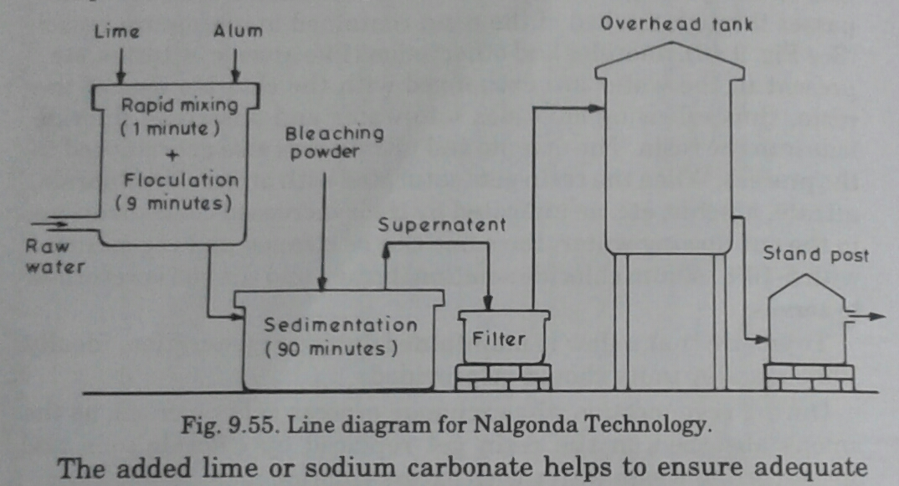

1. **Reverse osmosis:**

* Raw water passed through semi permeable membrane, which permits flow of water and blocks the salt water and also fluorides.
* RO is used for Desalination and rarely used for deflouridation.
* High cost, efficiency is also high.

**REMOVAL OF ARSENIC:**

* Permissible limits of arsenic in water is 0.05mg/lit. If it exceeds the limit problems to be faced are melanosis, lesion, arsenicosis.

**Removal methods of arsenic:**

1. Coagulation – precipitation technique by using aluminum and ferric salts.
2. Adsorption technique by AA or Ion exchange resins.
3. Membrane technology like RO and Electrodialysis.

Biological oxidation and photo oxidation both in presence of iron is removed for the removal of arsenic.

1. **Coagulation – precipitation technique:**

* Both trivalent arsenic i.e., As (III) and pentavalent arsenate i.e., As (V) are effectively removed by coagulation followed by sedimentation and filtration.
* As (V) is removed with equal efficiency, with both aluminum salts and iron salt as coagulant at pH < 7.5.
* However iron coagulants are found to be more effective than aluminum coagulants for the removal of As (V), with pH > 7.5 also As (III).
* As (III) can be easily removed by oxidizing into As (V) by pre-chlorination followed by coagulation using two coagulants.
* Drawback is arsenic will be deposited on filter sand and backwashing required frequently.
* Lime softening removes arsenic at pH 11, – entire removal of magnesium, arsenic is aheived.

1. **Adsorption technique by AA or Ion exchange resins:**

* Ordinary AA removes As (V) only. New AA will removes As(III) and As (V).
* Adsorption of arsenic (V) is affected by silicates (pH > 7) and phosphates with pH >7.
* Adsorption of arsenic (III) is affected by silicates (pH > 5) and phosphates with pH >6.
* Optimum pH range is 5.5 – 6.5.
* In AA method, raw passed is passed through granular beds same as de-fluoridation.
* After the saturation of AA, it is regenerated after washing water and with 1% caustic soda.
* Regenerated waste water is highly toxic, disposed properly after treatment. Regenerated water is treated with iron and aluminum salts, to get insoluble by reducing pH to 5.5 - 6.5

1. **Ion exchange method same as fluoride removal:**

* Water can be applied , if TDS is less than 500 mg/l and sulphates < 25 mg/l.
* Uses strong base anion exchange resin of chloride form pH – 8 and 9 which removes As(V).
* Resin is regenerated by using 5 – 10% of NaCl.
* Regenerated waste water is highly toxic, disposed properly after treatment. Regenerated water is treated with iron and aluminum salts, to get insoluble by reducing pH to 5.5 - 6.5.

1. **Membrane Technologies:**

* Membrane technologies includes RO and Electro-dialysis.
* Membranes prone to fouling by dissolved organic material, iron, manganese and suspended matter, before demineralization the water must be pretreated.
* Acid and sequestering agents such as sodium hexameta phosphate may be added to avoid scaling.
* Waste volume generated is high i.e. 10 to 25% of feed supply, this is the major draw back.
* Process is uneconomical, because pretreatment is required.